IKASE MARCO INSTALL

Open Microsoft Word

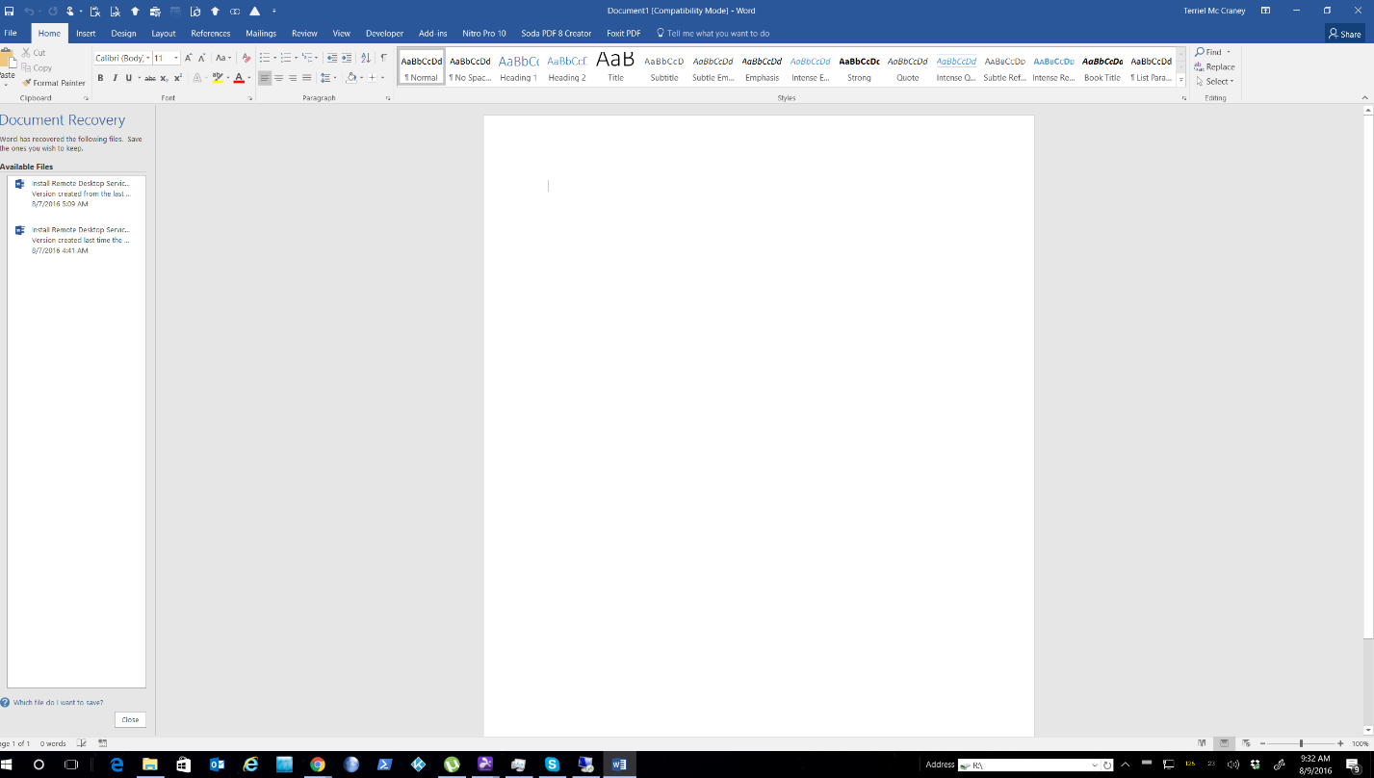

Press ALT Key While Simultaneously Pressing F11 To Open visual basic editor

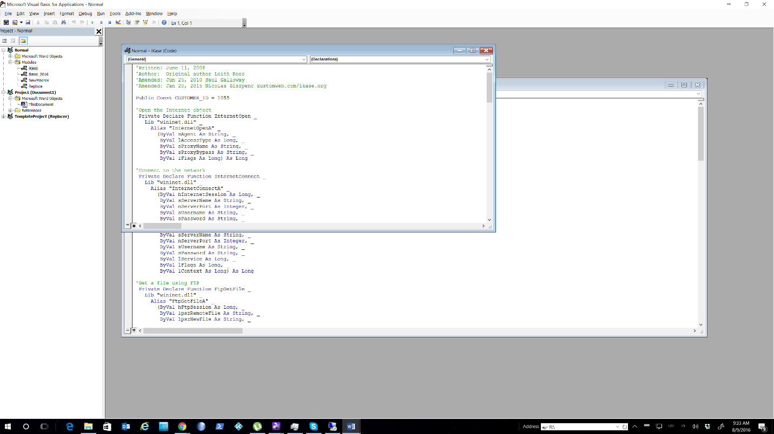
Right Click on “Normal” On Left Hand Panel to “Insert File”

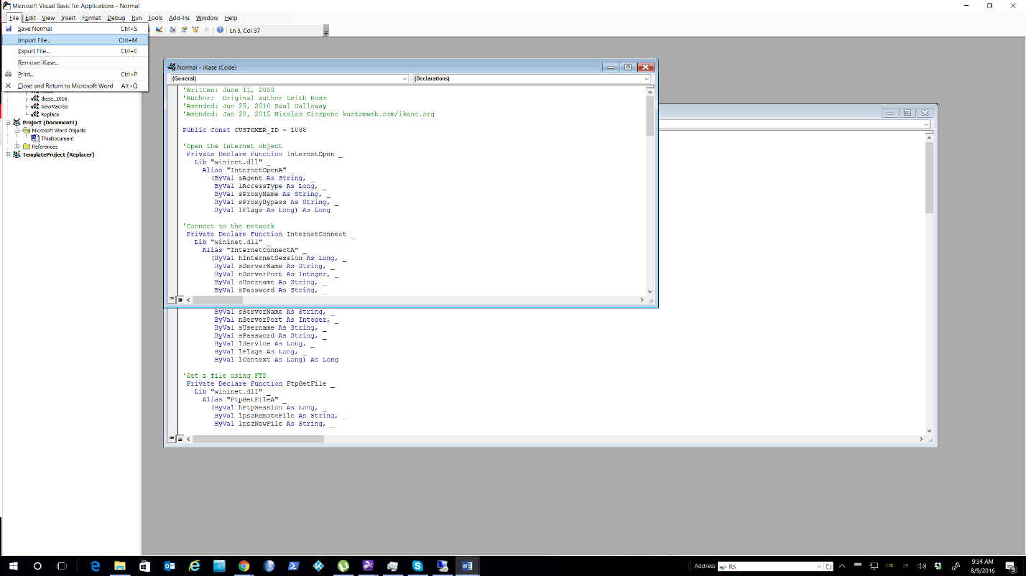

Browse To Ikase Macro, Click Open to Install
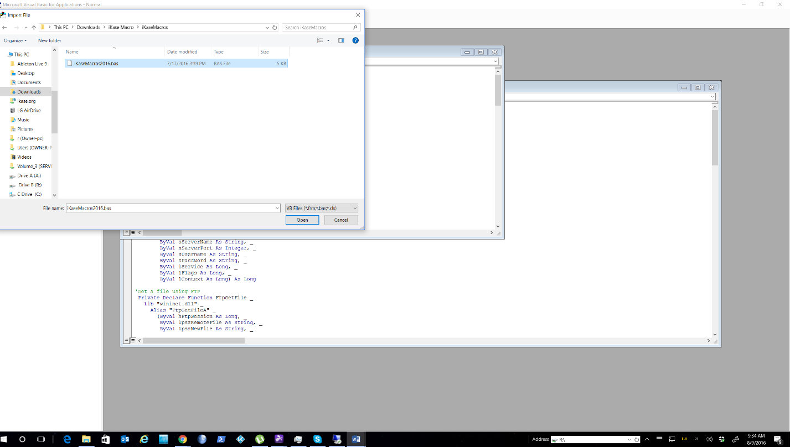

Change Customer ID to Your Ikase Customer ID (see Illustration Below)
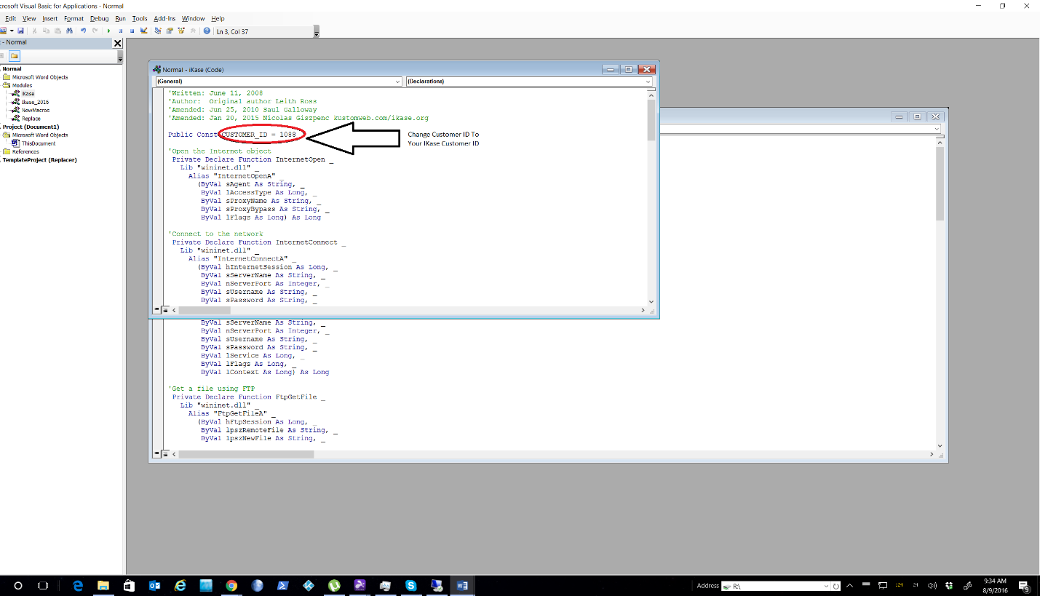

Close Visual Basic Editor, Return To Word

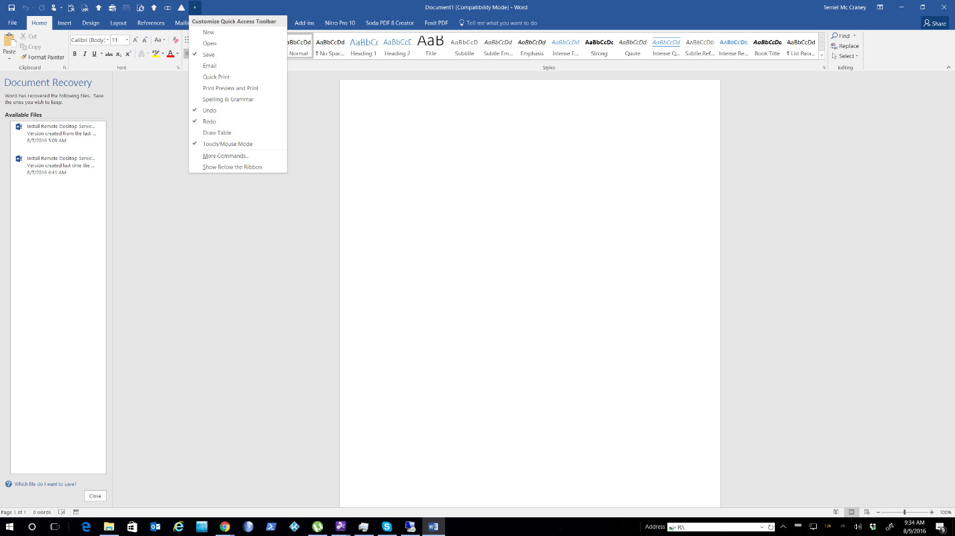

Click “Customize Quick Access” Tool Bar

Click “More Commands”
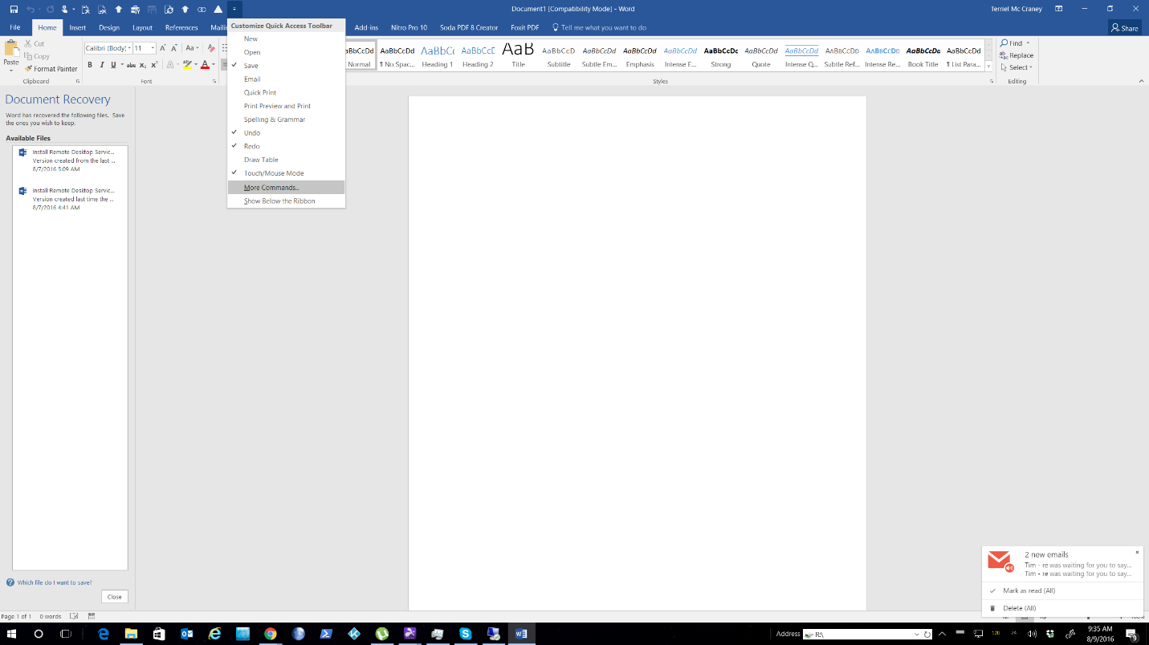

Click “Macros “
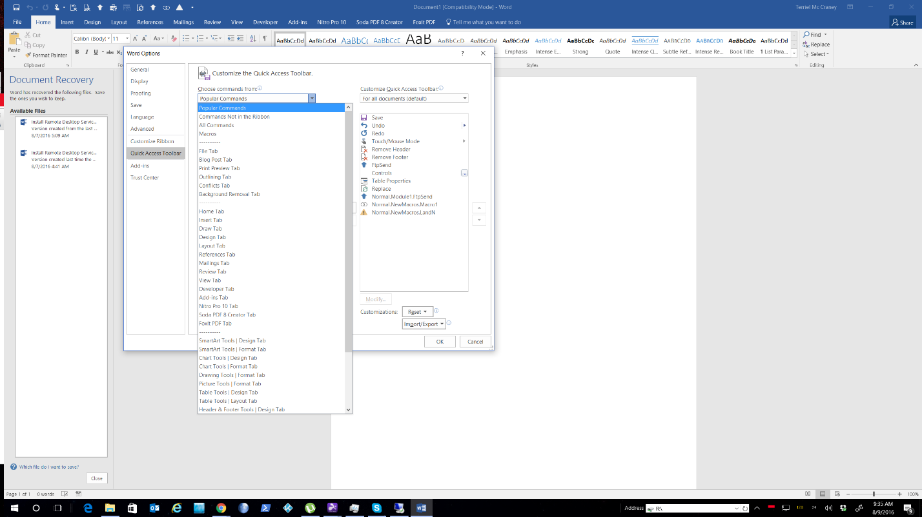

Double Click FTP Send
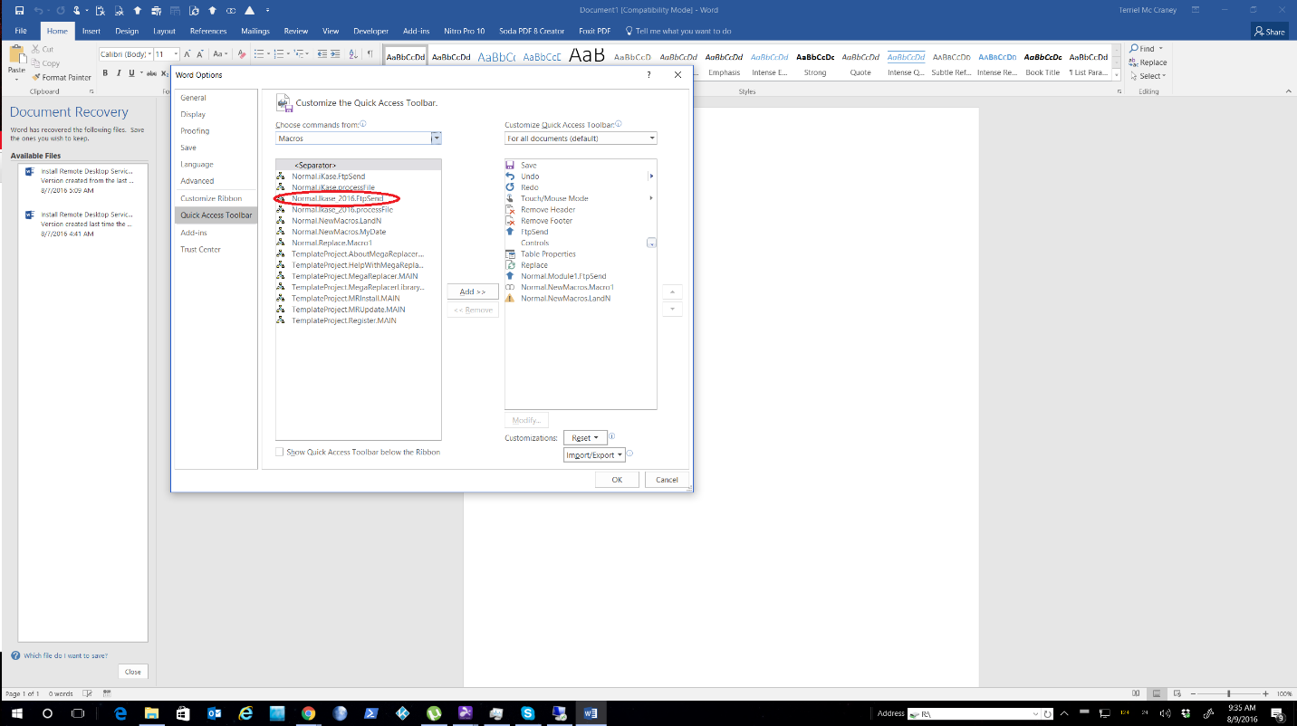

Click “Normal.Module1.FtpSend “ On the right panel, Then Click ”Modify” Below
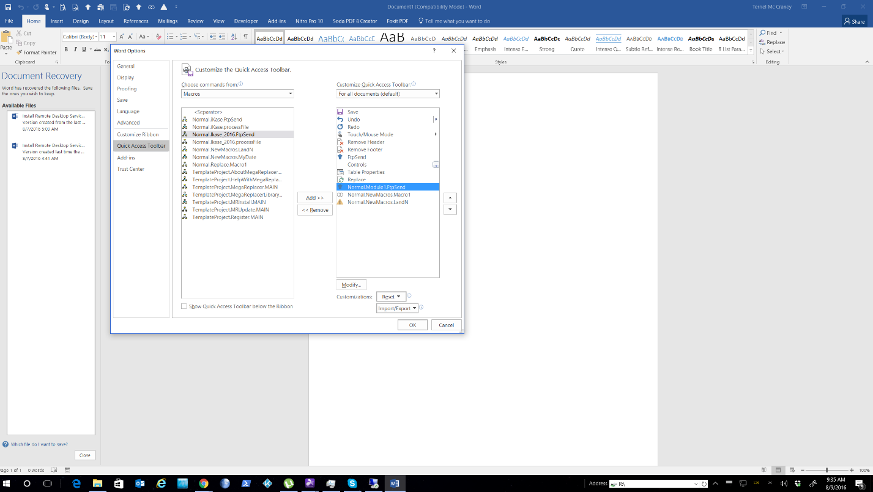

Click The Blue Up Arrow And Change The name To “Save To Ikase” , Then Click Ok In Small Dialog Box And Big Dialog Box
